# 16-720 Computer Vision Spring 2016

# Azarakhsh Keipour (akeipour@andrew) Assignment 5

## Q 1.1 Image gradients

The ‘mygradient’ function implements computation of the image gradients using  filter[[1]](#footnote-1). The visualization of the magnitude and orientation of test images ‘test0’ and ‘test1’ is shown in Fig. 1 and Fig. 2 respectively.

|  |  |
| --- | --- |
| C:\Users\Azarakhsh\Desktop\CMU\Vision\Homework 5\My Code\results\q1.1_test0_mag.png |  |

Figure 1. Visualization of the magnitude (left image) and orientation (right image) of test image ‘test0.jpg’.

|  |  |
| --- | --- |
| C:\Users\Azarakhsh\Desktop\CMU\Vision\Homework 5\My Code\results\q1.1_test1_mag.png |  |

Figure 2. Visualization of the magnitude (left image) and orientation (right image) of test image ‘test1.jpg’.

## Q 1.2 Histograms of gradient orientation

The visualization of the histograms of gradient orientations of test images ‘test0’ and ‘test1’ is shown in Fig. 3.

|  |  |
| --- | --- |
|  |  |

Figure 3. Visualization of histograms of gradient orientation of test images ‘test0.jpg’ (left) and ‘test1.jpg’ (right).

## Q 1.3 Detection

MATLAB does not support cross correlation output of the same size as one of the inputs, therefore it is easier to use conv2 function with one of the inputs (the smaller) rotated for 180 degrees instead of xcorr2.

I defined a function called ‘detectwh’ which does the detection (like ‘detect’ function) and additionally returns the heat map. The ‘detect\_script’ is slightly modified, so that in order to show the heat map as a result in the ‘detect\_script’ script, it is enough to uncomment the call to ‘detectwh’ function (where the ‘detect’ function is called).

The results of the detection function on all the test images along with their heat maps (cross-correlation response map) are shown in Fig. 4 – 10.

|  |  |
| --- | --- |
| C:\Users\Azarakhsh\Desktop\CMU\Vision\Homework 5\My Code\results\q1_3_test0_detection.png |  |

Figure 4. The result of the detection function (left) and the heat map (right) of ‘test0.jpg’ image.

|  |  |
| --- | --- |
|  |  |

Figure 5. The result of the detection function (left) and the heat map (right) of ‘test1.jpg’ image.

|  |  |
| --- | --- |
|  |  |

Figure 6. The result of the detection function (left) and the heat map (right) of ‘test2.jpg’ image.

|  |  |
| --- | --- |
|  |  |

Figure 7. The result of the detection function (left) and the heat map (right) of ‘test3.jpg’ image.

|  |  |
| --- | --- |
|  |  |

Figure 8. The result of the detection function (left) and the heat map (right) of ‘test4.jpg’ image.

|  |  |
| --- | --- |
|  |  |

Figure 9. The result of the detection function (left) and the heat map (right) of ‘test5.jpg’ image.

|  |  |
| --- | --- |
|  |  |

Figure 10. The result of the detection function (left) and the heat map (right) of ‘test6.jpg’ image.

## Q 1.4 Multiple detections

The modified script for multiple detections is in ‘detect\_script\_custom’. The only change is the names of the test files. The test image files used in this section are in the ‘custom’ folder. The ‘test100.jpg’ image is used to select the template and the ‘test101.jpg’ is used for detection. Test image ‘test100.jpg’ and the selected template are shown in Fig. 11. The two detections on the ‘test101.jpg’ and the associated heat map are shown in   
Fig. 12.

|  |  |
| --- | --- |
| C:\Users\Azarakhsh\Desktop\CMU\Vision\Homework 5\My Code\results\q1_4_test100_grayscale.png |  |

Figure 11. The original image ‘test100.jpg’ (left) and the selected template (right).

|  |  |
| --- | --- |
|  |  |

Figure 12. The result of 2 detections (left) and the heat map (right) of ‘test101.jpg’ image.

## Q 2.1 Select Patches

The function asks interactively from the user to input the number (and names) of images and the number of positive and negative examples for each image. The function makes the user selections of the positive examples square. Then it randomly selects the intended number of negative examples. The result of the function on the test images ‘test0.jpg’ and ‘test1.jpg’ with the selected areas on the image is shown in Fig. 13.

|  |  |
| --- | --- |
|  |  |

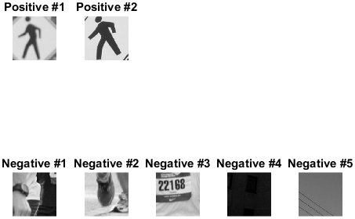

Figure 13. The selected positive (green) and negative (red) areas on the test images ‘test0.jpg’ (top left) and ‘test1.jpg’ (top right) with the resulted positive and negative resized examples (bottom).

## Q 2.2 Positive template learning

The result of the detection using the positive templates of the Fig. 13 on the test image ‘test6.jpg’ is shown in the Fig. 14.

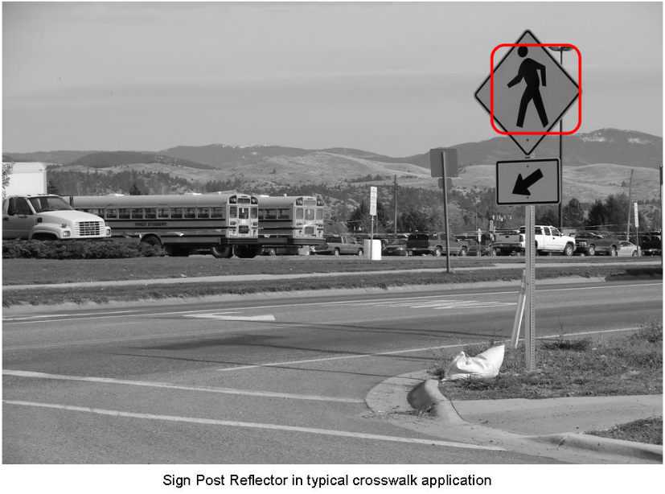

Figure 14. The selected positive (green) and negative (red) areas on the test images ‘test0.jpg’ (top left) and ‘test1.jpg’ (top right) with the resulted positive and negative resized examples (bottom).

## Q 2.3 Positive negative template learning

1. As suggested in:

   N. Dalal and B. Triggs, "Histograms of oriented gradients for human detection," Computer Vision and Pattern Recognition, 2005. CVPR 2005. IEEE Computer Society Conference on, San Diego, CA, USA, 2005, pp. 886-893 vol. 1. [↑](#footnote-ref-1)